Push Button
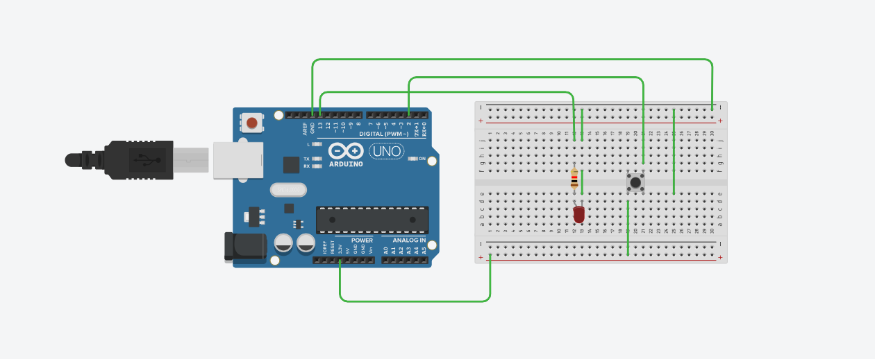

int led = 13;
int pushButton = 2;

void setup() {
Serial.begin(9600);
pinMode(pushButton, INPUT);
pinMode(led, OUTPUT);
}

void loop() {
int buttonState = digitalRead(pushButton);
Serial.println(buttonState);

if (buttonState == HIGH) {
digitalWrite(led, HIGH); // Turn LED ON
delay(500); // Stay ON for half a second
digitalWrite(led, LOW); // Turn LED OFF
delay(500); // Stay OFF for half a second
} else {
digitalWrite(led, LOW); // Keep LED OFF if button not pressed
}
}

